# GradFolioLocalDB Setup

1. Create Database Called GradFolioLocalDB
2. Add Connection string to Webconfig in the GradFolio.web

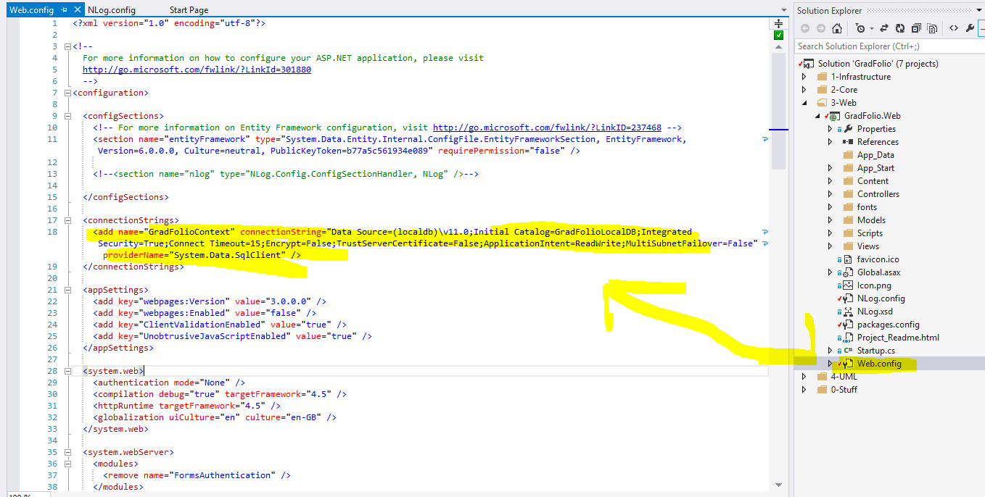

1. Add Connection string to Appconfig in GradFolio.Infrastructure

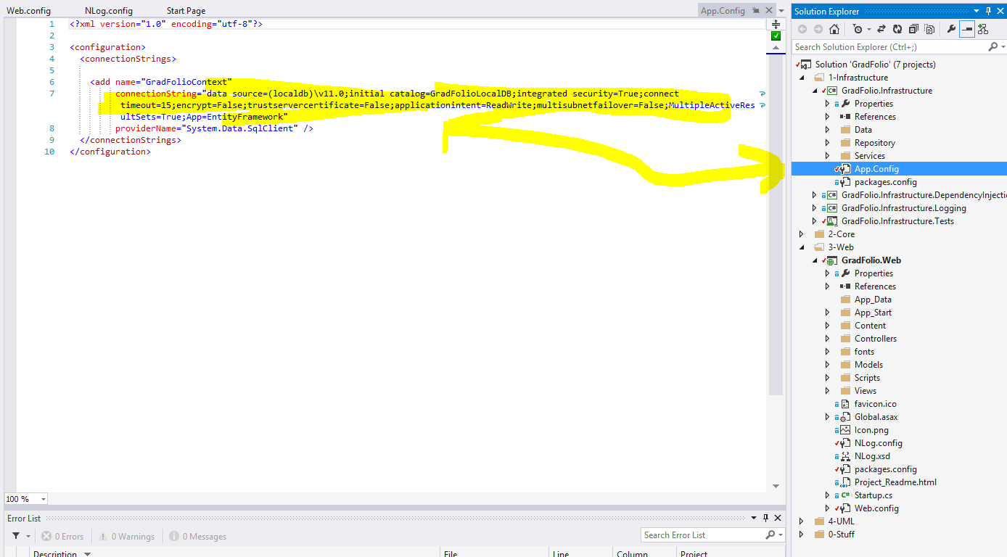

1. Run application and register a new account. The Asp Security tables will be generated.
2. Stop application and run GradFolio SQL Script to add additional tables.

# NLog Database setup

1. Create Database Called Logging
2. Modify the connection string below:
3. Run Nlog SQL Script

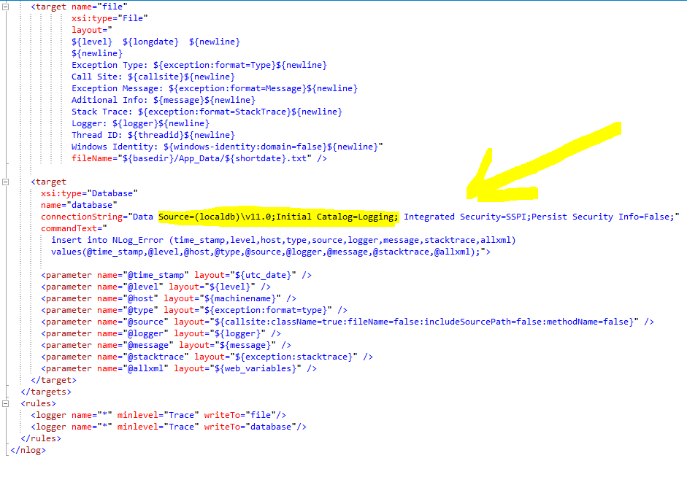

# Alternatively

**Attack Database files located in folder and modify config files according to previous steps**